**Day 2: 27-06-2025**

JavaScript was object based or prototype or function base interpreter scripting language before ES5 version.

From ES6 onward JavaScript also known as object oriented interpreter scripting language.

ECMA : European computer manufacture association. ES is a concept.

JS is one of the implementation of ES.

Mainly JS use to do validation on client machine.

With help of JS we can do dynamic task on client machine

<http://www.gmail.com> ---🡪

req(http/https)---🡪

Client Server

🡨---Res(http/https)

JavaScript Syntax

<script type=”text/JavaScript”> opening tag

document.write(“Welcome to JS”);

</script> closing tag

This tag we can write in between head or body tags. In one html we can write more than one Script tag. document is a pre defined object and write is pre defined function. Which is use to display message through JS on browser. In JS it is not mandatory every statement end with semi colon.

Data types : data type is as type of data which tells what type of value it can hold.

To declare the variable in JS before ES6 we were using var keyword. from ES6 onward we are using let and const keyword.

var a; by default value undefined.

var n=10; number type consider

var m=10.10 number type consider

var result = true; Boolean type

var fname = “Ravi Kumar”; string type consider

var obj = new Date(); object type consider

document.write(a);

**operator**

arithmetic operator : +, -, *, /, %

conditional operator : >, >=, <, <=, ==, !=

assignment operator : =

equality operator : ===

increment and decrement operator : ++, --

**conditional statement**

1. If statement
2. If else
3. If else if
4. Switch statement

**Looping**

While loop

Do while loop

For loop

Function : function is use to write set of instruction to perform specific task.

In JS function mainly divided into two types.

1. Pre defined or built in function
2. User defined function

**Pre defined functions**

1. alert(“Msg”): this function is use to display pop up message.
2. prompt(): this function is use to take the value through keyboard.
3. parseInt() : convert string to integer without decimal
4. parseFloat() : convert string to float with decimal
5. eval() : convert string to number
6. confirm() : it contains 2 button. If we click on ok it return true. If we click on cancel it return false.

do {

1:Add 2 :Sub using alert display choice

Using prompt take the choice options

switch(choice) {

1: take the value of a and b and convert using eval display sum

2: take the value of a and b and convert using eval display sub

default : wrong choice

}

Using confirm do you want to continue Y/N

}while()

Using alert 🡪 thank you

User defined function

1. Normal function creation using function keyword.

function functionName(parameterList){

function body;

}

1. Function with no passing parameter and no return type.
2. Function passing parameter no return type
3. Function passing parameter and return value.

**Event** : it provide the bridge between html tags (DOM elements document object model) and JS code. Whenever use interact with any html component or tags different type of action or event generate. When these event generate we need to provide event listener to listen generated event. Listener are generally normal functions.

Type of events : in JS all event start with pre-fix on followed by event names.

onClick : button

onDblClick : button

onMouseOver : image

onMouseOut : image

onKeyUp : text field or password field, text area

onKeyDown : keyboard event

onChange : drop down

onSubmit : form validation

onBlur : text field

onFocus

etc

**JS Object**

Object : any real world entity

In JS if we want to implements object concept we can use 3 ways

1. Using literal style object creation ES5 style
2. Function style object creation ES5 style
3. Class style object creation ES6 style

In JS object mainly divided into 2 types

1. Pre defined object
2. User defined object

Pre defined object

JS provided to JS object hierarchy

BOM : Browser Object Model

DOM : Document Object model

Object -🡪 Property (state)

Behaviour (functions)

Object --🡪 Property

Behaviour

Object -🡪 property

Behaviour

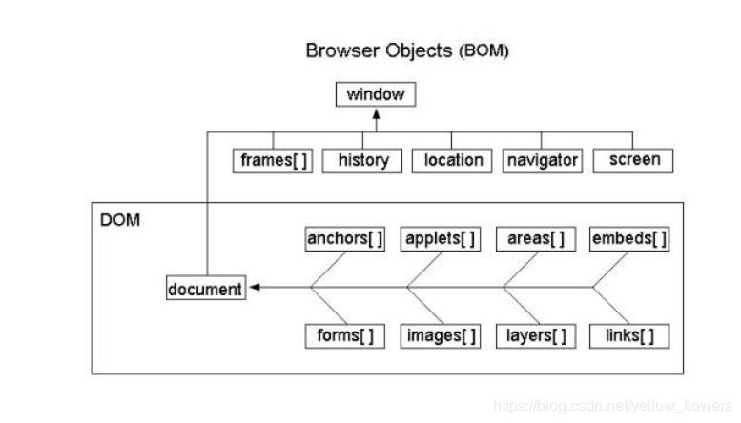

DOM Operation : document object provided lot of pre defined function which help to read, write and update html or dom contents dynamically.

DOM parser : Lot of programming language like Java, Python, C#, JS provided lot of pre defined function which help to read, write and update html or dom contents dynamically.

**Index.html**

Html root tag

Head body

Meta div

Title p

Style p contents

Script div

**document.getXX**